Brian Engel

UI Wireframe

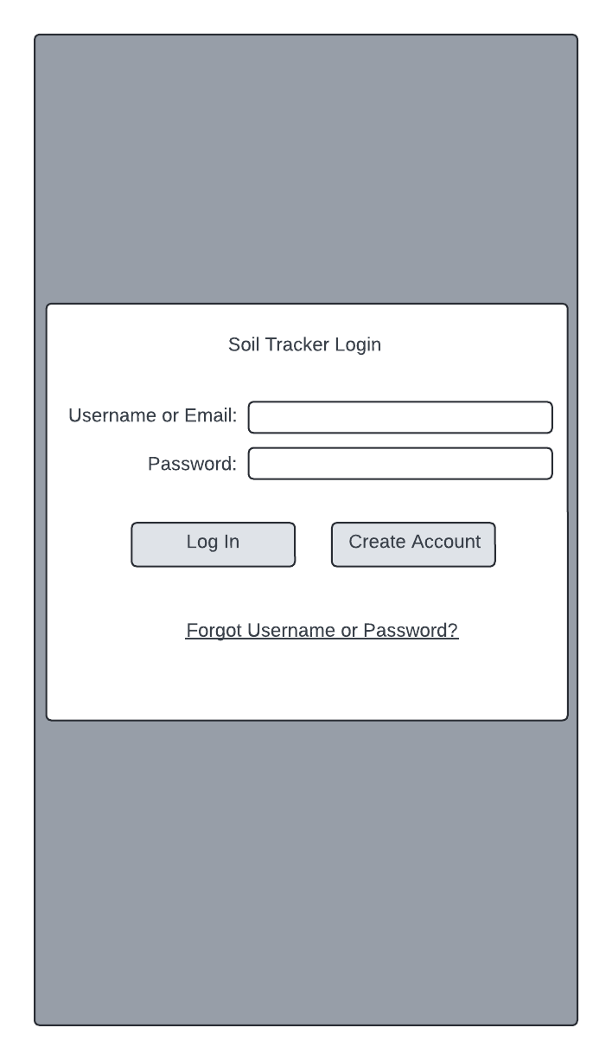

The initial page will be the login page. There is a text input for both the username/email and the password. Then there are buttons to login or create an account. After that there is a link for if you forgot either of the required pieces of information. Pressing the login button will take you to the main page of the app if the credentials are valid.

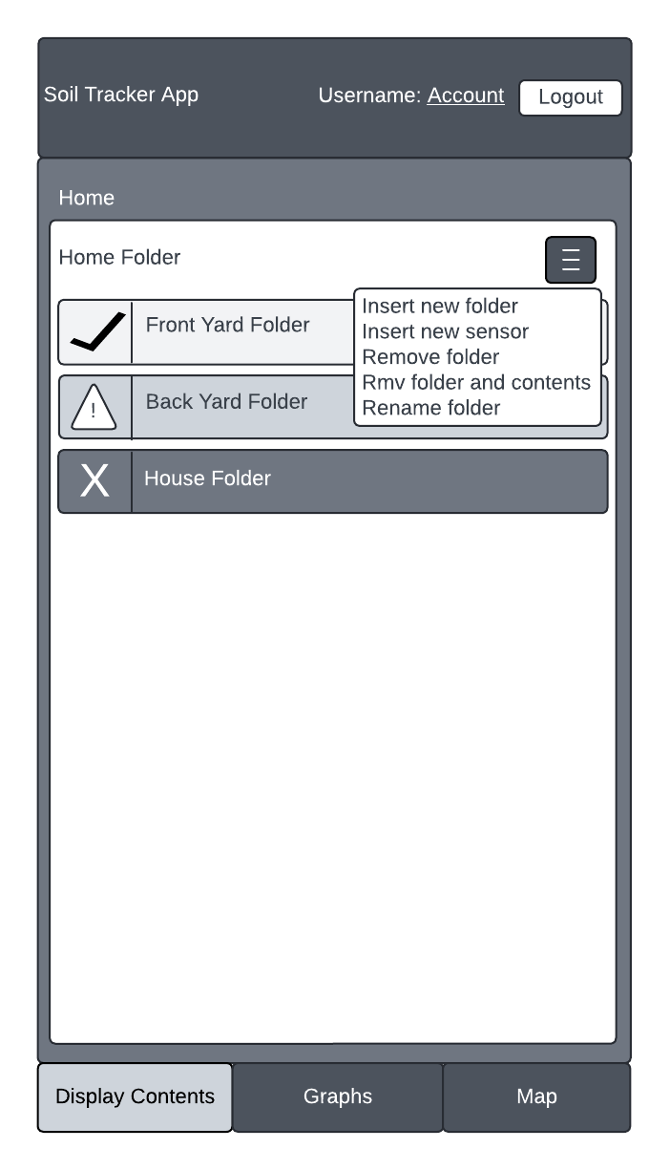

The main page of the app. The header and bottom buttons will appear on every screen. The header will be a dark version of the primary color, and includes the app name, the current user, a link to change account settings, and a button to logout. The bottom buttons will also be a dark version of the primary color, except the one selected which will be a light version of the primary color. Next is a medium colored area that will primarily be used for a breadcrumb trail for backward navigation. Since we are at the top level right now it won't really do anything, but if we clicked into the front yard folder it would become "Home > Front Yard" and you could click home to get back to it. Inside that in white is the top folder that contains the folder name, a menu for folder maintenance and adding sensors to it (as displayed in the white dropdown menu that won't appear until you click the hamburger menu which is dark primary color), and all the menus and sensors that you have created in it. These folders and sensors are buttons that can be clicked to make them the top level of the UI. It basically works like the file system on your computer to keep things organized and gives you the freedom to set it up anyway you want, including naming them. While you can name the folders and sensors anything you want, the word folder or sensor will always be appended end to help keep clear what is being clicked into. The color of these buttons will depend on the status of the sensors that are further down in the structure. If there is sensor that has an alarm, it will be red with the X icon next to it. If there is a sensor that has a warning, it will be yellow with a caution icon next to it. If everything is good, it will be green with a check icon next to it.

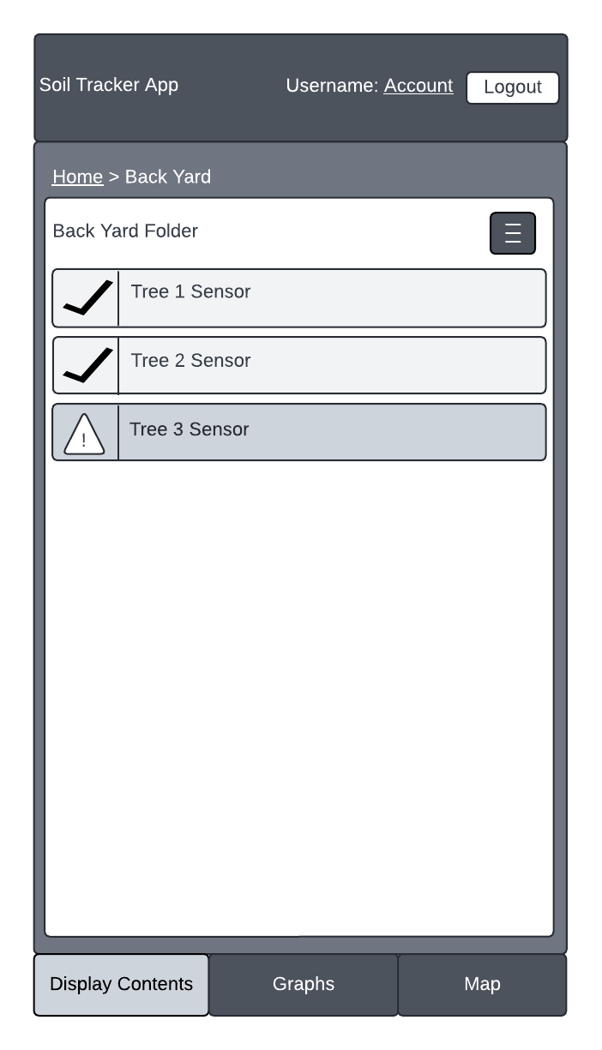

This is the screen that would appear if you clicked Back Yard folder on the main screen. I just wanted to demonstrate the updated breadcrumb trail and Back Yard folder becoming the top level folder.

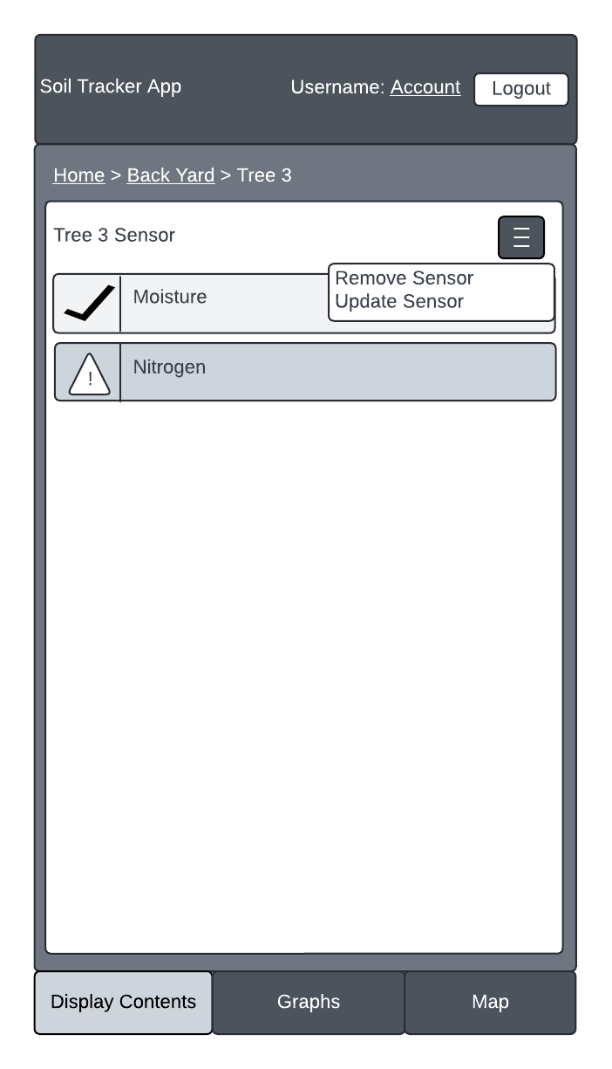

This is the screen that would appear if you clicked Tree 3 sensor in the Back Yard folder. I wanted to demonstrate the updated breadcrumb trail and Tree 3 Sensor folder becoming the top level and being able to see the condition of moisture and nitrogen levels. It also demonstrates what the hamburger menu will contain for a sensor, since that is different from the folder hamburger menu.

This page is for the graph for tree 3. It shows the updated color on the bottom buttons to indicate what tab you are on. There are no new navigational buttons on this page and is primarily used for displaying data.

This is the page that will display when a user clicks either insert new sensor from the hamburger menu on the folder page or update sensor form the hamburger menu on the sensor page. The main difference between the two is that on insert sensor there will be nothing populated in the menu initially and if cancelled a sensor will not be added. On the update sensor the form will be populated with the sensor’s current information and if cancelled will keep the sensor as it was. There is a text box to input a sensor name. Then there is a dropdown to either choose custom nitrogen and moisture levels if you are a professional and know what they are supposed to be for a given type of plant, or you can choose from a list of plants that have predetermined acceptable levels for that type of plant if you don’t know. This was a main thing that my users wanted since most people don’t know. The connect sensor button below is really just a place holder since we have to connect a sensor for every sensor we set up, but I have no idea of the information needed or process for that at this time. Below this is the cancel and done buttons to complete the operation. Also when on this screen all navigation will be disabled until cancel or done are pressed, such as the bottom buttons and the breadcrumb trail.